TITLE

AUTHOR–AUTHOR

abstract abstract abstract abstract abstract abstract abstract abstract abstract abstract abstract abstract abstract abstract abstract abstract abstract abstract abstract abstract abstract abstract abstract abstract abstract abstract abstract abstract abstract abstract abstract abstract abstract abstract abstract abstract abstract abstract abstract abstract abstract abstract abstract abstract abstract abstract abstract abstract abstract abstract abstract abstract abstract abstract.
Keywords: keyword1, keyword2, keyword3, keyword4, keyword5

Introduction
Introduction Introduction Introduction Introduction Introduction Introduction Introduction Introduction Introduction Introduction Introduction Introduction Introduction Introduction Introduction Introduction Introduction Introduction.
Introduction Introduction Introduction Introduction Introduction Introduction Introduction Introduction Introduction Introduction Introduction Introduction Introduction Introduction Introduction Introduction Introduction Introduction Introduction Introduction Introduction Introduction
Introduction Introduction Introduction Introduction Introduction Introduction Introduction Introduction Introduction Introduction Introduction Introduction Introduction Introduction Introduction Introduction Introduction Introduction Introduction Introduction Introduction Introduction Introduction Introduction Introduction

1. Materials and methods

1.1 Measuring device

1.2 ……

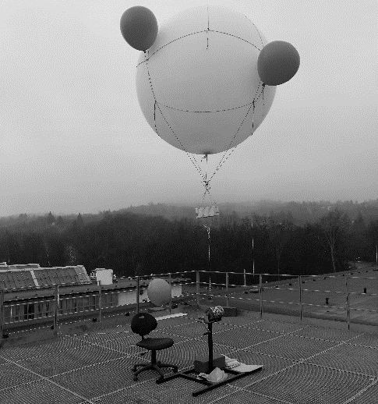
Figure 1. Test box and the compiled measuring system

Table 1.Effect of meteorological variables to PM10 concentration [1]

Conclusion
Conclusion Conclusion Conclusion Conclusion Conclusion Conclusion Conclusion Conclusion Conclusion Conclusion Conclusion Conclusion

Acknowledgements
Acknowledgements Acknowledgements Acknowledgements Acknowledgements Acknowledgements

References
IEEE style
[1] B. Klaus and P. Horn, Robot Vision. Cambridge, MA: MIT Press, 1986.
[2] L. Stein, “Random patterns,” in Computers and You, J. S. Brake, Ed. New York: Wiley, 1994, pp. 55-70.
[3] L. Bass, P. Clements, and R. Kazman, Software Architecture in Practice, 2nd ed. Reading, MA: Addison Wesley, 2003. [E-book] Available: Safari e-book.
[4] J. U. Duncombe, "Infrared navigation - Part I: An assessment of feasabi-lity," IEEE Trans. Electron. Devices, vol. ED-11, pp. 34-39, Jan. 1959.
[5] H. K. Edwards and V. Sridhar, "Analysis of software requirements engineering exercises in a global virtual team setup," Journal of Global Information Manage-ment, vol. 13, no. 2, p. 21+, April-June 2005. [Online]. Available: Academic OneFi-le, http://find.galegroup.com. [Accessed May 31, 2005].
[6] A. Altun, "Understanding hypertext in the context of reading on the web: Langu-age learners' experience," Current Issues in Education, vol. 6, no. 12, July 2003. [Online]. Available: http://cie.ed.asu.edu/volume6/number12/. [Accessed Dec. 2, 2004].
[7] L. Liu and H. Miao, "A specification based approach to testing polymorphic attributes," in Formal Methods and Software Engineering: Proceedings of the 6th International Conference on Formal Engineering Methods, ICFEM 2004, Seattle, WA, USA, November 8-12, 2004, J. Davies, W. Schulte, M. Barnett, Eds. Berlin: Springer, 2004. pp. 306-19.
[8] T. J. van Weert and R. K. Munro, Eds., Informatics and the Digital Society: Soci-al, ethical and cognitive issues: IFIP TC3/WG3.1&3.2 Open Conference on Social, Ethical and Cognitive Issues of Informatics and ICT, July 22-26, 2002, Dortmund, Germany. Boston: Kluwer Academic, 2003.
[9] J. Riley, "Call for new look at skilled migrants," The Australian, p. 35, May 31, 2005. [Online]. Available: Factiva, http://global.factiva.com. [Accessed May 31, 2005].
[10] J. H. Davis and J. R. Cogdell, “Calibration program for the 16-foot antenna,” Elect. Eng. Res. Lab., Univ. Texas, Austin, Tech. Memo. NGL-006-69-3, Nov. 15, 1987.
[11] J. P. Wilkinson, “Nonlinear resonant circuit devices,” U.S. Patent 3 624 125, July 16, 1990.
[12] IEEE Criteria for Class IE Electric Systems, IEEE Standard 308, 1969.
[13] J. O. Williams, “Narrow-band analyzer,” Ph.D. dissertation, Dept. Elect. Eng., Harvard Univ., Cambridge, MA, 1993.

institute address e-mail
institute address e-mail

